Simple jQuery example of using jQuery to select specific css3 selectors and add objects with things to do and for the selected div, added a method called addClass so that can use jQuery to add the class ( I added two classes) to that specific css selector in the html, then can use the css to manipulate the newly added classes.

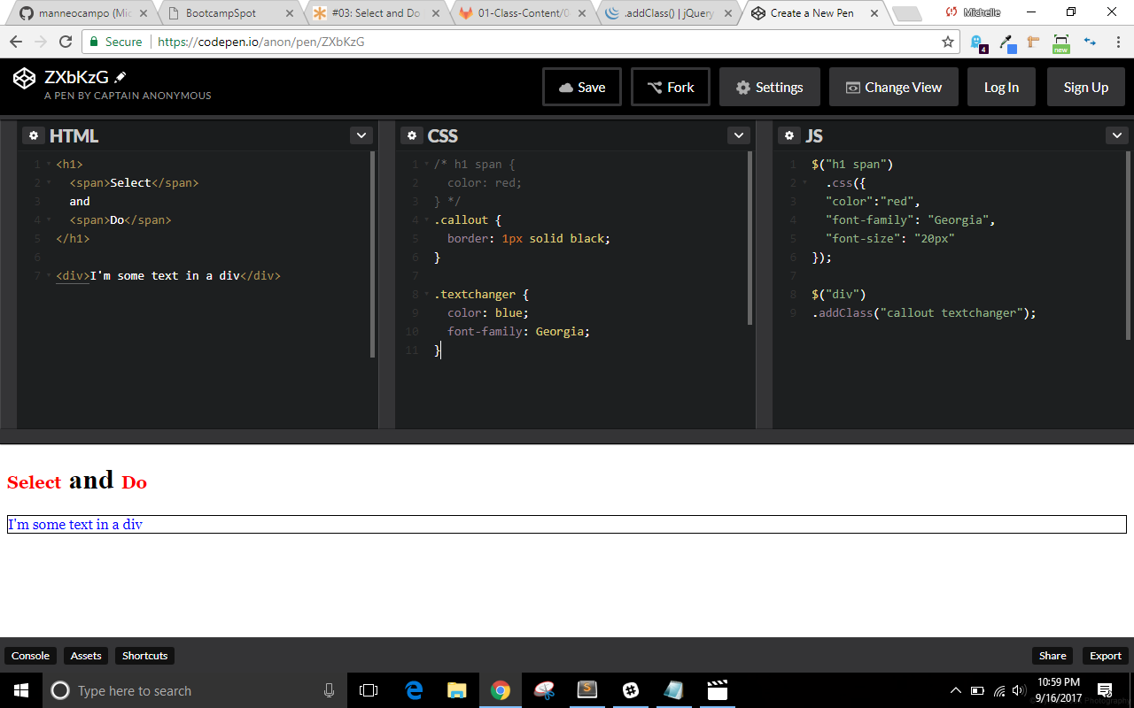

Example of selecting an attribute (href) and adding a method (.on) with two parameters (“click”, and function) then adding what you want to do to that selector when someone clicks. Added the id of what you wanted to select again and the to-do with the .toggle method. The toggle will show if hidden and hide if shown.

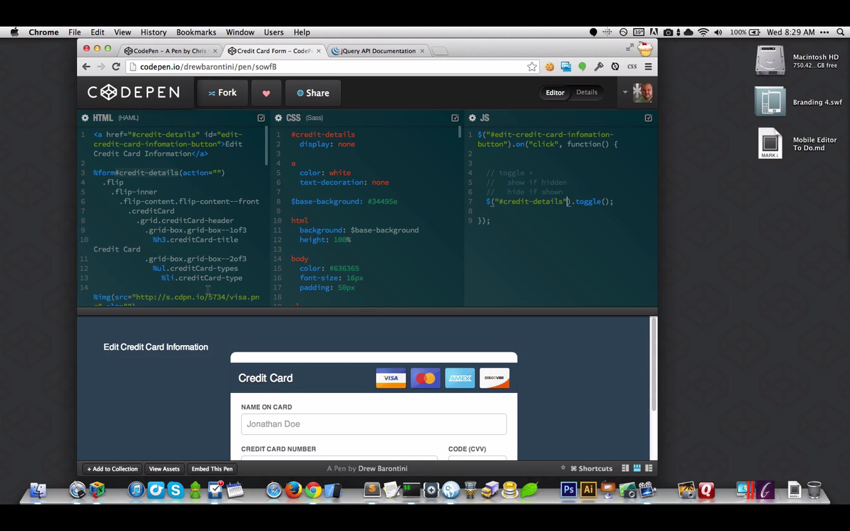

Moving active class using jQuery and this (refers to the nav a you are clicking on) – so like you can reassign the active class to “this one[of the nav a tags]”

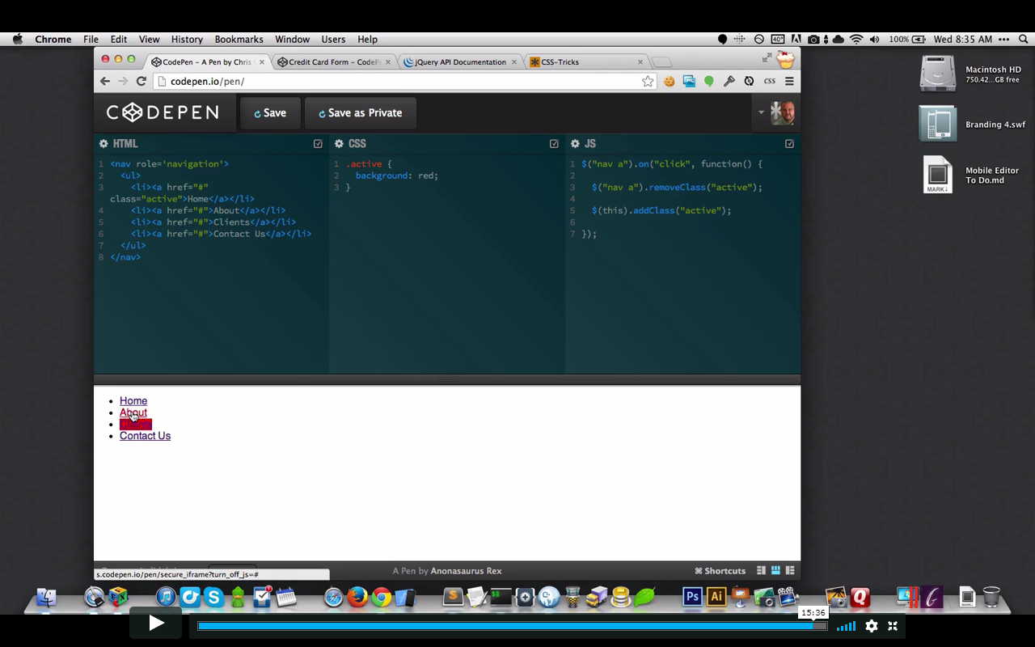

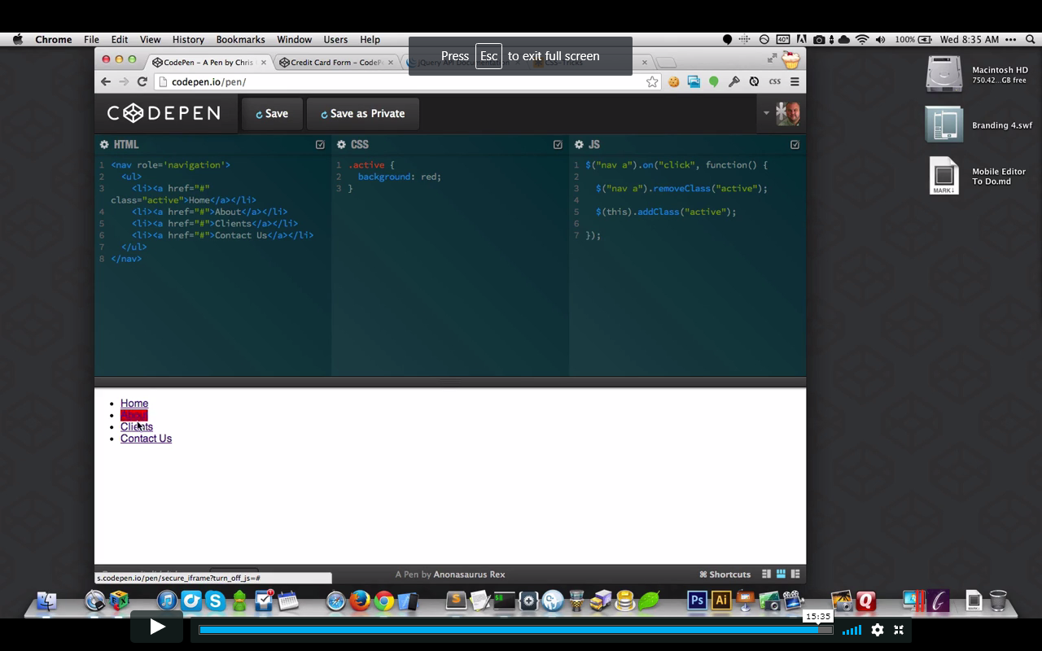

Return false does both event.preventDefault(); and event.stopPropagation(); --(preventDefault prevents the default actions for the webpage and stopPropagation will stop bubbling up like if have ul and li items with anchors in each li and place the stopPropagation at the anchor then whatever action you wanted to change with the event won’t also bubble up into the li or the ul tags.)

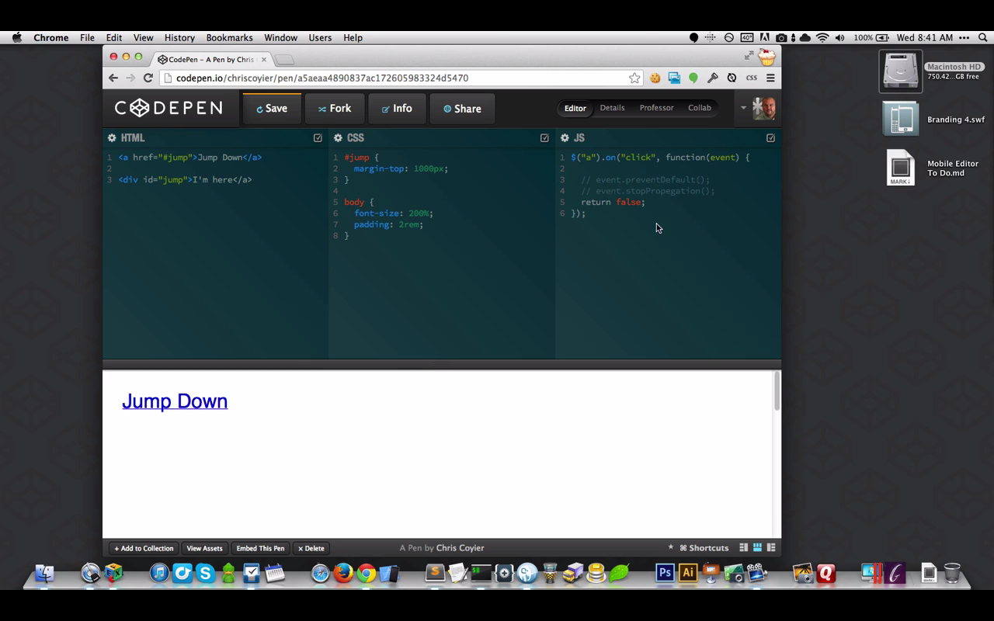

This is for getters and setters: .height() will get the height of the id selected but if you pass a parameter thru () then you are making it a setter. He said if we think about it, it isn’t really different from if we made a function and put a parameter. In the function break down below: if a is defined then do setter stuff, else return a value (do getter stuff). So basically if there is a value I am gonna set something for them and if there is no value then I am gonna get something for them.

